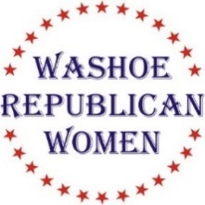
KIDS KOTTAGE
DONATIONS NEEDED !!!
Underwear
Socks
For Teen Girls & Boys
Bring to Luncheon on September 15th
KIDS KOTTAGE
DONATIONS NEEDED !!!
Underwear
Socks
For Teen Girls & Boys
Bring to Luncheon on September 15th

Washoe Republican Women (WRW)

invite you to attend our luncheon meeting
Wednesday, September 15th, 2021
Speakers & Honored Guest:
Michele Fiore Sigal Chattah Jim DeGraffenreid
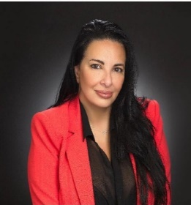
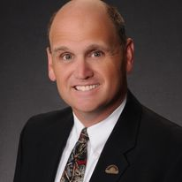

Michele Fiore is the NVGOP National Committeewoman & the Ward 6 representative on the Las Vegas City Council. She is a former Nevada State Assemblywoman, having represented District 4 from 2012 to 2016. Michele is a staunch 2nd Amendment advocate.
Sigal Chattah was born in Israel in 1975 and emigrated to Nevada with her family when she was 14 years old. She is a graduate of Valley High School in Las Vegas, University of Nevada Las Vegas, and the Widener University School of Law in Harrisburg, Pennsylvania.
Jim DeGraffenreid is the NVGOP National Committeeman and longtime Nevada businessman. He lives in Gardnerville with his wife.

Rattlesnake Club
606 W. Plumb, Reno

Social time at 11:00 am. Lunch at 11:40 am. Program starts at 12:00 Noon.

$30 WRW Members w/reservation $35 Non-Members w/reservation

Seating is First Come, First Served

RSVP NLT 12 Noon on September 12th: Lindy Leonard @ 775-901-1172, or lindyleonard@charter.net, or wrw.rsvp@gmail.com

Non-attendance or failure to cancel after the above date/time you will be invoiced $40.00
Check, cash, or credit card accepted at the door!
(This is not a fundraising event for any political candidate)

