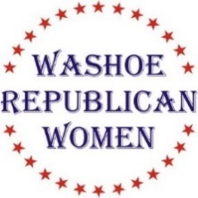
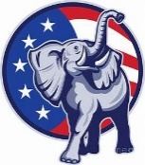
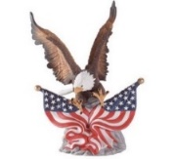
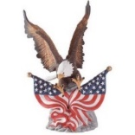
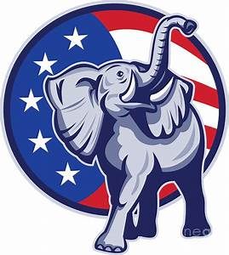

Washoe Republican Women (WRW)

invite you to attend our luncheon meeting

Wednesday, October 20th, 2021

Guest Speaker:
Annie Black

Republican Assemblywoman Annie Black previewed her fierce independence just days after the 2020 election when she announced her decision not to join the Republican Assembly Caucus in order to speak our freely and forcibly during the session. At the start of the session, the freshman from Mesquite immediately introduced a bill to terminate Gov. Sisolak’s “state of emergency” and regularly badgered the Democrats to open the legislature to the public. Annie also proposed; eliminating the state business license, creating a legislative committee solely focused on recommending cuts to non-essential spending, and requiring all bills be posted online for at least 48 hours before being voted on. Her principled refusal to provide a “vaccine passport” at the end to the session resulted in Democrats temporarily stripping her of the ability to vote on bills or speak from the floor of the Assembly chamber. Her wildly popular “AnnieGram” newsletter (www.AnnieBlack.net) kept constituents informed of the goings-on throughout the session as “Annie’s Army” of supporters spread throughout the state of Nevada. The Nevada Policy Research Institute (NPRI), Nevada’s oldest and respected think tank, named Annie as the #1 conservative legislator for the 2021 session, and the ACLU Nevada Chapter named her the least friendly to their agenda.

Rattlesnake Club
606 W. Plumb, Reno

Social time at 11:00 am. Lunch at 11:40 am. Program starts at 12:00 Noon.

$30 WRW Members w/reservation $35 Non-Members w reservation

Seating is First Come, First Served

RSVP NLT 12 Noon on October 16th Glenda Gilmore @ (707) 249-3076, or ggilmore44@gmail.com or wrw.rsvp@gmail.com

Non-attendance or failure to cancel after the above date/time you will be invoiced $40.00
Check, cash, or credit card accepted at the door!

(This is not a fundraising event for any political candidate)

