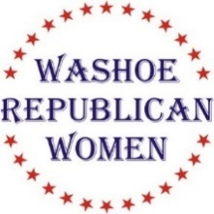
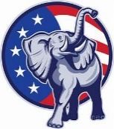
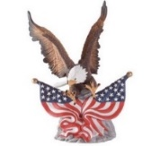
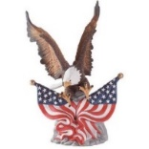
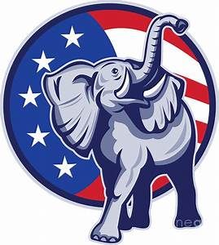

Washoe Republican Women (WRW)

invite you to attend our luncheon meeting

Wednesday, November 17th, 2021

Guest Speaker:
Marsha Strand & Mona Crandell Hook
“Quilts of Valor”
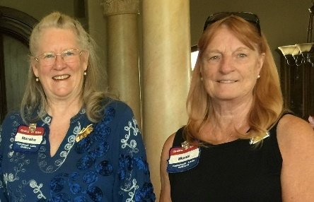
Marsha, Mona, and 5 other patriotic women formed the Comstock Lode Quilters in 2015 with the goal of providing unique, one of a kind, “Quilts of Valor”, to military veterans being recognized by Honor Flight Nevada. Marsha was a guardian escort for her veteran father during an Honor Flight Oregon event several years ago. Upon his return her father was presented with a “Quilt of Valor” and was so moved by the presentation of his quilt that she decided to do the same for our returning Honor Flight Nevada heroes. To date Marsha, Mona, and their team have presented 1,059 handmade patriotic quilts to northern Nevada Veterans. Marsha & Mona are both members of; the Daughters of the American Revolution, the Colonial Dames 17th Century, the Jamestown Society, The Daughters of the War of 1812, and The Daughter of the Civil War and the Daughters of the Confederacy. Crowning a fascinating legacy, Mona’s lineage traces to one of the Salem Witches. Mona lives in Tahoe Vista and loves books, entertaining, and is reported to be a fabulous cook.

Rattlesnake Club
606 W. Plumb, Reno

Social time at 11:00 am. Lunch at 11:40 am. Program starts at 12:00 Noon.

$30 WRW Members w/reservation $35 Non-Members w reservation

Seating is First Come, First Served

RSVP NLT 12 Noon on November 13th Lindy Leonard @ (775) 901-1172, or lindyleonard@charter.net or wrw.rsvp@gmail.com

Non-attendance or failure to cancel after the above date/time you will be invoiced $40.00
Check, cash, or credit card accepted at the door!

(This is not a fundraising event for any political candidate)

