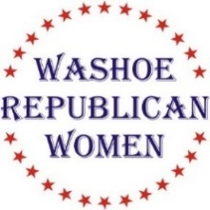
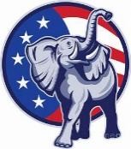
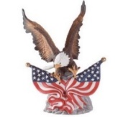
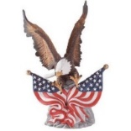
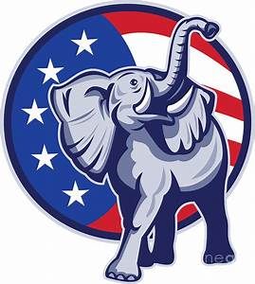

Washoe Republican Women (WRW)

invite you to attend our luncheon meeting

Wednesday, August 18th, 2021
Guest Speaker:
Deborah Paul
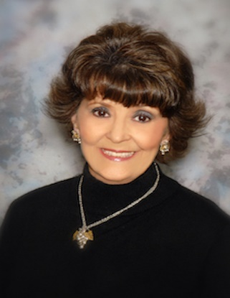

Deborah Paul has played with ink since she was able to read and write. At 19, after two years of college, she left St. Louis to fly for American Airlines, and later enjoyed a long career with Flying Tiger Lines in many capacities, including flying military and their dependents all over the world as a flight attendant. Paul returned to university in the 1990s earning a journalism degree from Cal State University Dominguez Hills and was eventually hired as a newspaper reporter for the South Bay Weekly section of the Los Angeles Times. A decade later she worked for Orange Coast Magazine as their Charitable Events editor. She also taught journalism and was advisor to the campus newspaper at CSUDH and still contributes as a regular stringer for Peninsula News on the Palos Verdes Peninsula. Currently, she has self-published four-of-five children's books in her ballad series. Her poetic fictional stories are inspired by real people who have left an indelible mark on the quiet display of simple human kindness. She resides in Rancho Palos Verdes married to Jim, her husband of many adventures.
Rattlesnake Club
606 W. Plumb, Reno

Social time at 11:00 am. Lunch at 11:40 am. Program starts at 12:00 Noon.

$30 WRW Members w/reservation $35 Non-Members w reservation

Seating is First Come, First Served

RSVP NLT 12 Noon on August 14th Lindy Leonard @ 775-901-1172, or lindyleonard@charter.net, or wrw.rsvp@gmail.com

Non-attendance or failure to cancel after the above date/time you will be invoiced $40.00
Check, cash, or credit card accepted at the door!

(This is not a fundraising event for any political candidate)

